Python Exercise:

Step 1: created a directory named python test.

Created hello.py file as per the requirement.

Used the below content in hello.py file

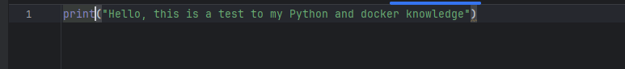

Step 2: we have to create a docker file.

The above mentioned is the code in docker file.

Step 3: Build the Docker image

Open a terminal or command prompt.

Navigate to the folder where you have your hello.py file and Dockerfile.

Run this command: docker build -t my_python_app .

This command tells Docker to create an image based on the instructions in your Dockerfile.

It gives the image a name or "tag" called my_python_app.

Step 4: Run the Docker container

After the image is built, you can run a container using the following command:

Run: docker run my_python_app

This command instructs Docker to start a container based on the my_python_app image.

Because the Dockerfile specifies to run hello.py, you'll see the message "Hello, this is a test to my Python and docker knowledge" printed in the terminal.

We can see the requirement in the terminal.